PROJECT 3
SQL DATA ANALYSIS
SQL-based extraction, aggregation and business insight

Analysis Report
Dataset: Sales / Order Transactions

Contents
1. Dataset Overview
2. Product Performance
3. Customer Behaviour
4. Payment Behaviour
5. Marketing Performance
6. Order-Status Analysis
7. Time-Based Analysis

1. Dataset Overview

Business Question
What is the overall commercial scale and coverage of the dataset?

Analytical Questions
• How many orders are recorded in the dataset?
• How many unique customers are represented?
• What period does the dataset cover?
• What is the total sales value recorded?
• What is the average order value?

SQL Query
SELECT
COUNT(*) AS Total_Orders,
COUNT(DISTINCT CustomerID) AS Unique_Customers,
MIN(Date) AS First_Order_Date,
MAX(Date) AS Last_Order_Date,
SUM(TotalPrice) AS Total_Sales_Value,
AVG(TotalPrice) AS Average_Order_Value
FROM sales;

Query Result

Key Insight
The dataset contains 1,200 orders generated by 1,189 unique customers and covers the period from 1 January 2023 to 30 June 2025. Across this period, the recorded orders represent a total sales value of 1,264,761.96, with an average order value of 1,053.97. These figures establish the overall scale, customer coverage and time range used as the baseline for the subsequent analyses.

2. Product Performance

Business Question
How do products differ in demand, sales contribution, and order value?

Analytical Questions
• How is order activity distributed across the different products?
• What is the total sales value generated by each product?
• What is the average order value associated with each product?
• Which products stand out in terms of sales value, order volume and average order value?

SQL Query
SELECT
Product,
SUM(TotalPrice) AS total_sales,
AVG(TotalPrice) AS average_order_value
COUNT(*) AS number_of_orders
FROM sales
GROUP BY Product
ORDER BY total_sales DESC;

Query Result
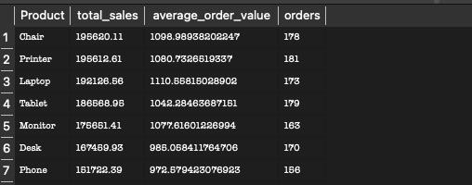

Key Insight
Product performance differs depending on the metric used. Chair ranked first by total sales value, narrowly ahead of Printer, while Printer recorded the highest order volume at 181 orders. Laptop ranked third by total sales but recorded the highest average order value at approximately 1,110.86 per order, showing that higher-value transactions can offset lower order volume. Phone recorded the lowest order volume at 156 orders and the lowest average order value at approximately 972.68. Overall, the results demonstrate that total sales, order frequency and order value identify different dimensions of product performance.

3. Customer Behaviour

Business Question
How frequently do customers place orders, and what does the customer base look like in terms of purchasing frequency?

Analytical Questions
• How does the customer base differ between one-time and repeat purchasers?
• How much sales activity comes from each group?

SQL Query
SELECT
CASE
WHEN order_count = 1 THEN 'One-time customer'
ELSE 'Repeat customer'
END AS customer_type,
COUNT(*) AS number_of_customers,
SUM(order_count) AS total_orders,
SUM(total_spend) AS total_sales,
SUM(total_spend) / SUM (order_count) AS average_order_value
FROM (
SELECT
CustomerID,
COUNT(*) AS order_count,
SUM(TotalPrice) AS total_spend,
AVG(TotalPrice) AS average_order_value
FROM sales
GROUP BY CustomerID
) AS customer_summary
GROUP BY customer_type
ORDER BY total_sales DESC;

Query Result
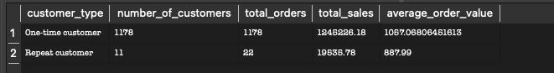

Key Insight
The customer base is overwhelmingly composed of one-time purchasers. Of the 1,189 unique customers identified in the dataset, 1,178 were one-time customers, while only 11 placed more than one order. One-time customers accounted for 1,178 orders and generated 1,245,326.18 in sales, compared with 22 orders and 19,535.78 in sales from repeat customers. The results therefore show that sales activity is heavily concentrated among one-time purchases. From a business perspective, this pattern could support further investigation into customer retention and repeat-purchase opportunities, although the SQL results alone do not establish why repeat purchasing is limited.

4. Payment Behaviour

Business Question
How does order value and activity differ across payment methods?

Analytical Questions
• Which payment methods are used most frequently?
• Which payment methods contribute the greatest total sales value?
• How does average order value differ across payment methods?

SQL Query
SELECT
PaymentMethod,
COUNT(*) AS number_of_orders,
SUM(TotalPrice) AS total_sales,
AVG(TotalPrice) AS average_order_value
FROM sales
GROUP BY PaymentMethod
ORDER BY total_sales DESC;

Query Result
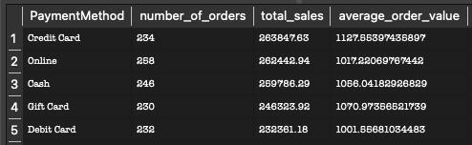

Key Insight
Payment activity is relatively evenly distributed across the five payment methods. Online recorded the highest order volume at 258 orders, followed by Cash at 246 and Credit Card at 234. Despite having fewer transactions than Online and Cash, Credit Card generated the highest total sales value at 263,847.63 and the highest average order value at approximately 1,127.56. Debit Card recorded the lowest average order value at approximately 1,001.57. The results show that the most frequently used payment method is not necessarily the method associated with the greatest sales value or transaction value.

5. Marketing Performance

Business Question
Which acquisition sources attract the most valuable order activity, and how is coupon usage distributed across them?

Analytical Questions
• Which referral sources generate the most orders and sales?
• How does coupon usage vary across referral sources?
• Which referral-source/coupon combinations generate the greatest sales value?

SQL Query 1
SELECT
ReferralSource,
COUNT(*) AS number_of_orders,
SUM(TotalPrice) AS total_sales,
AVG(TotalPrice) AS average_order_value
FROM sales
GROUP BY ReferralSource
ORDER BY total_sales DESC;

Query Result
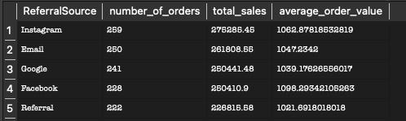

SQL Query 2
SELECT
ReferralSource,
CouponCode,
COUNT(*) AS number_of_orders,
SUM(TotalPrice) AS total_sales,
AVG(TotalPrice) AS average_order_value
FROM sales
GROUP BY ReferralSource, CouponCode
ORDER BY total_sales DESC;

Query Result
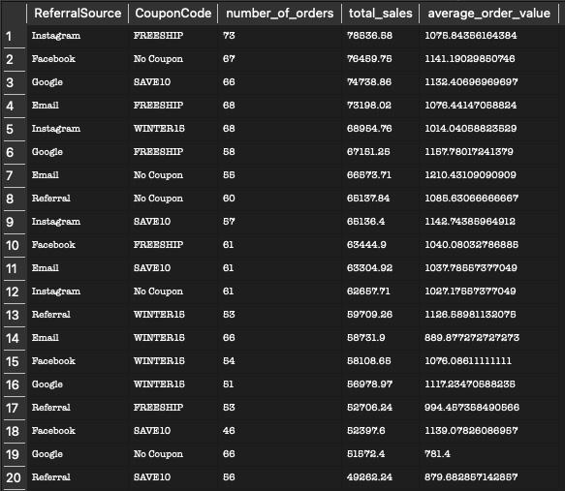

Key Insight
The analysis identifies Instagram as the strongest acquisition source overall, with 259 orders and the highest total sales value at approximately 275,286.45. Email followed with 250 orders and approximately 261,808.65 in sales, while Google generated 241 orders and approximately 250,441.48. Facebook recorded fewer orders than Email and Google but had a relatively high average order value of approximately 1,098.29, the highest among the referral sources; Referral recorded the lowest overall activity, with 222 orders and approximately 228,815.68 in sales.
Coupon usage varied across acquisition sources. FREESHIP was the most frequently associated coupon for Instagram and Email, with 73 and 68 orders respectively. Facebook's largest category was No Coupon with 67 orders; Google recorded 66 orders each for SAVE10 and No Coupon; and Referral recorded its highest usage with No Coupon at 60 orders. At the referral-source/coupon level, Instagram + FREESHIP produced the highest total sales value at 78,536.58 from 73 orders, followed by Facebook + No Coupon at 76,459.75 from 67 orders and Google + SAVE10 at 74,738.86 from 66 orders. Email + No Coupon recorded the highest average order value at approximately 1,210.43. Overall, the findings show that acquisition volume, total sales and average transaction value can highlight different aspects of marketing performance.

6. Order-Status Analysis

Business Question
How does order status affect the distribution of order activity and sales value, and where is sales activity potentially being lost or left unresolved?

Analytical Questions
• Which order statuses account for the most orders and sales value?
• How does average order value differ across order statuses?
• How much order activity and sales value is associated with completed, in-progress, returned, or cancelled orders?

SQL Query
SELECT
OrderStatus,
COUNT(*) AS number_of_orders,
SUM(TotalPrice) AS total_sales,
AVG(TotalPrice) AS average_order_value
FROM sales
GROUP BY OrderStatus
ORDER BY total_sales DESC;

Query Result
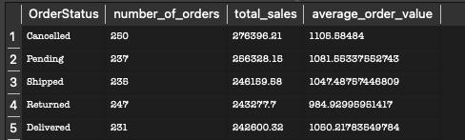

Key Insight
Order activity is relatively evenly distributed across the five statuses, with no single status accounting for a dominant share. Cancelled orders recorded the highest volume at 250 and the highest total sales value at 276,396.21, with an average order value of approximately 1,105.68. Pending orders followed with 237 orders and 256,838.16 in sales, while Shipped accounted for 235 orders and 241,619.88 in sales. Returned orders accounted for 247 orders and approximately 243,277.70 in sales, while Delivered recorded 231 orders and 242,600.32 in sales, with an average order value of approximately 1,050.22.
The results highlight a substantial amount of recorded order value associated with cancelled, pending and returned orders rather than delivered orders alone. However, these figures should be interpreted as recorded order value, not automatically as realised or lost revenue, because the dataset does not establish whether cancelled or returned orders were refunded. The analysis therefore provides an important operational perspective: fulfilment outcomes should be considered alongside sales activity when assessing overall business performance.

7. Time-Based Analysis

Business Question
When does the business experience its strongest and weakest periods of order activity and sales performance?

Analytical Questions
• How does order activity and sales value vary across time?
• Which months generate the highest and lowest sales values?
• Are periods with more orders necessarily the periods with the greatest sales value?

SQL Query 1
SELECT
strftime('%Y-%m', Date) AS order_month,
COUNT(*) AS number_of_orders,
SUM(TotalPrice) AS total_sales,
AVG(TotalPrice) AS average_order_value
FROM sales
GROUP BY order_month
ORDER BY total_sales DESC
LIMIT 5;

Query Result
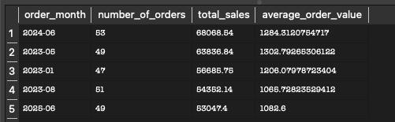

SQL Query 2
SELECT
strftime('%Y-%m', Date) AS order_month,
COUNT(*) AS number_of_orders,
SUM(TotalPrice) AS total_sales,
AVG(TotalPrice) AS average_order_value
FROM sales
GROUP BY order_month
ORDER BY total_sales ASC
LIMIT 5;

Query Result
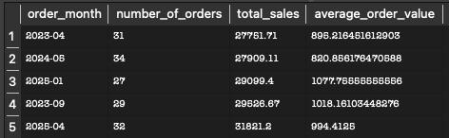

Key Insight
Sales performance varied considerably across individual months. June 2024 was the strongest-performing month, generating 68,068.54 in sales from 53 orders, with an average order value of approximately 1,284.31. May 2023 followed with 63,836.84 in sales from 49 orders and an average order value of approximately 1,302.79. Other strong-performing months were January 2023, with 56,865.75 in sales from 47 orders; August 2023, with 54,352.14 from 51 orders; and June 2025, with 53,047.40 from 49 orders.
At the lower end, April 2023 recorded the lowest sales value at 27,751.71 from 31 orders, followed by August 2024 at 27,909.11 from 34 orders. January 2025 generated 29,099.40 from 27 orders, September 2023 generated 29,526.67 from 29 orders, and April 2025 generated 31,821.20 from 32 orders. The comparison demonstrates that order volume alone does not determine sales performance: for example, January 2025 had fewer orders than April 2023 but a higher average order value. Overall, the time-based results reveal substantial month-to-month variation and reinforce the importance of considering both transaction volume and transaction value.

Conclusion
The SQL analysis provides a structured view of the dataset from seven complementary perspectives: overall scale, product performance, customer behaviour, payment behaviour, marketing performance, order status and time-based performance. Across these analyses, the results show that business performance is not captured by a single measure. Order volume, total sales value and average order value frequently identify different leaders, while customer purchasing frequency, acquisition source, promotional behaviour and fulfilment status add further context to the observed sales activity.
Together, the queries demonstrate how SQL can be used to move from raw transactional records to targeted business questions, measurable results and evidence-based interpretation.
Interpretation note: The analysis describes patterns observed in the dataset and does not establish causation. Recorded order value should also not automatically be interpreted as realised revenue where an order is cancelled or returned.

